**Project Design Phase-II Technology Stack (Architecture & Stack)**

|  |  |
| --- | --- |
| Date | 20-06-2025 |
| Team ID | LTVIP2025TMID21133 |
| Project Name | ShopEZ : One-Stop Shop For Online Purchases |
| Maximum Marks | 4 |

**Data Flow Diagram**

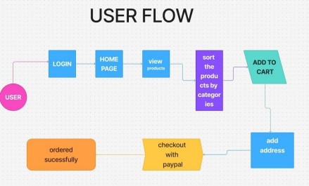The ShopEZ application is designed to accommodate three primary user roles: Customer, and Admin. Each role has specific responsibilities and permissions, managed through dedicated user flows and API endpoints. Below is an overview of the application flow for each role.

1. Admin Flow

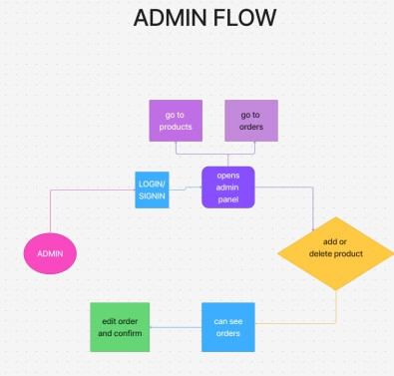

**User Stories**

|  |  |  |  |  |  |  |  |  |  |  |
| --- | --- | --- | --- | --- | --- | --- | --- | --- | --- | --- |
|  |  | **User Type** | **Function al** | **User Story** | **User**  **Story /** | **Accepta nc e** | **Priori t** | **Releas e** |  |  |
|  | **Require**  **me nt** | **Num**  **b** | **Task** | **Criteria** | **y** |
|  | **(Epic)** | **er** |  |  |  |
| Customer (Mobile/ | Registration | USN- 1 | As a user, I can register | I can access | High | Sprint 1 |
| We b) |  |  | with email, | my |  |
|  |  |  | password, | account |  |
|  |  |  | and | / |  |
|  |  |  | confirm  password | dashboar  d |  |

|  |  |  |  |  |  |  |  |  |  |  |
| --- | --- | --- | --- | --- | --- | --- | --- | --- | --- | --- |
|  |  |  |  | USN- | As a user, I | I can click | High | Sprint 1 |  |  |
| 2 | will receive | the |  |
|  | a | confirmati |  |
|  | confirmati | on link |  |
|  | on email | and |  |
|  | once I | verify my |  |
|  | register | account |  |
|  |  | USN- | As a user, I | I can | Low | Sprint 2 |
| 3 | can register | access |  |
|  | using | my |  |
|  | LinkedIn | dashboa |  |
|  |  | rd using |  |
|  |  | LinkedIn |  |
|  |  | login |  |
|  |  | USN- | As a user, I | I can access my  dashboa rd using  Gmail login | Mediu m | Sprint 1 |
| 4 | can register |
|  | using Gmail |
|  | Login | USN- | As a user, I | I can log | High | Sprint 1 |
|  | 5 | can log in | in and |  |
|  |  | with email | access |  |
|  |  | and password | my |  |
|  |  |  | dashboar |  |
|  |  |  | d |  |
|  | Dashboar | USN- | As a user, I | I can | High | Sprint 1 |
| d | 6 | can view | browse |  |
|  |  | products | listings |  |
|  |  | and offers | and add |  |
|  |  | on my | items to |  |
|  |  | dashboard | my cart |  |
|  | Product | USN- | As a user, I | I can see | High | Sprint 1 |
| Search & | 7 | can search | filtered |  |
| Filtering |  | for | results |  |
|  |  | products by | based on |  |
|  |  | name, | search |  |
|  |  | brand, or | keywords |  |

|  |  |  |  |  |  |  |  |  |  |  |
| --- | --- | --- | --- | --- | --- | --- | --- | --- | --- | --- |
|  |  |  |  |  | category |  |  |  |  |  |
|  | Cart & Checkout | USN- 8 | As a user, I can | I can  update | High | Sprint 1 |
|  |  | add/remo | items and |  |
|  |  | ve items | proceed |  |
|  |  | to my | to |  |
|  |  | cart, | payment |  |
|  |  | modify |  |  |
|  |  | quantity, |  |  |
|  |  | and |  |  |
|  |  | checkout |  |  |

|  |  |  |  |  |  |  |  |  |  |  |
| --- | --- | --- | --- | --- | --- | --- | --- | --- | --- | --- |
|  |  |  | Order | USN- | As a user, I | I can see | High | Sprint 2 |  |  |
| Tracking | 9 | can track | statuses |  |
|  |  | my order | like |  |
|  |  | status in | Processi |  |
|  |  | real-time | ng, |  |
|  |  |  | Dispatch |  |
|  |  |  | ed , |  |
|  |  |  | Delivered |  |
| Customer | Customer | USN | As a | Custome | Mediu m | Sprint 2 |
| Care | Support | 10 | support | rs |
| Executive |  |  | agent, I | receive |
|  |  |  | can | respons |
|  |  |  | respond to | es |
|  |  |  | customer | within |
|  |  |  | complaints | 24 |
|  |  |  | and queries | hours |
| Administ | Inventory | USN | As an | Products | High | Sprint 1 |
| rat or | Manage | 11 | admin, I | update |  |
|  | me nt |  | can | instantly |  |
|  |  |  | add/edit/d | across |  |
|  |  |  | ele te | customer |  |
|  |  |  | product | dashbo |  |
|  |  |  | details and | ard s |  |
|  |  |  | inventory |  |  |

|  |  |  |  |  |  |  |  |  |  |  |
| --- | --- | --- | --- | --- | --- | --- | --- | --- | --- | --- |
|  |  |  | User  Manage me nt | USN 12 | As an  admin, I  can manage user  accounts  and handle complaints | I can  suspend, activate, or delete user accounts | High | Sprint 2 |  |  |